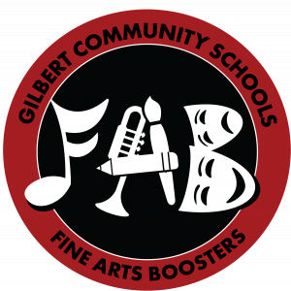
Gilbert High School
Fine Arts Boosters
2021 Scholarship Application
Name:
Phone: E-Mail:

Gilbert Fine Arts Participation
Please specify details about your participation in each box that applies. For example, instrument/part/chair for band, specific role for plays/musicals, groups for large group speech, etc.
 | Freshman | Sophomore | Junior | Senior
Instrumental
concert band, jazz band, pep band, color guard, contest
Vocal
choir,
Tiger Voices,
contest
Drama
musicals,
plays,
Variety Show
Speech
individual,
group
Art
classes,
Art Club
Other
dance team, writing, etc.

Essay Section
What do you consider to be your top Fine Arts achievements/honors at Gilbert?
Describe your community involvement in the Fine Arts:
How has your involvement in the Fine Arts enhanced your life and that of others?
How do you envision continuing your involvement in the Fine Arts in the next 5-10 years?

Application deadline is Friday, April 23rd.
Please limit completed form to two pages. Scholarships must be used for qualified education expenses, including tuition, fees, and course-related expenses. E-mail completed application to info@gilbertfab.org.

